Day 29

DIY

Q1. How to set the CloudWatch alarms for Amazon SNS metrics?

Problem Statement:

CloudWatch also allows you to set alarms when a threshold is met for a metric.For example, you can set the alarm for metrics,NumberOfNotificationsFailed, so that when your specified threshold number is met within the sampling period, then an email notification will be sent to inform you of the event.

Solution –

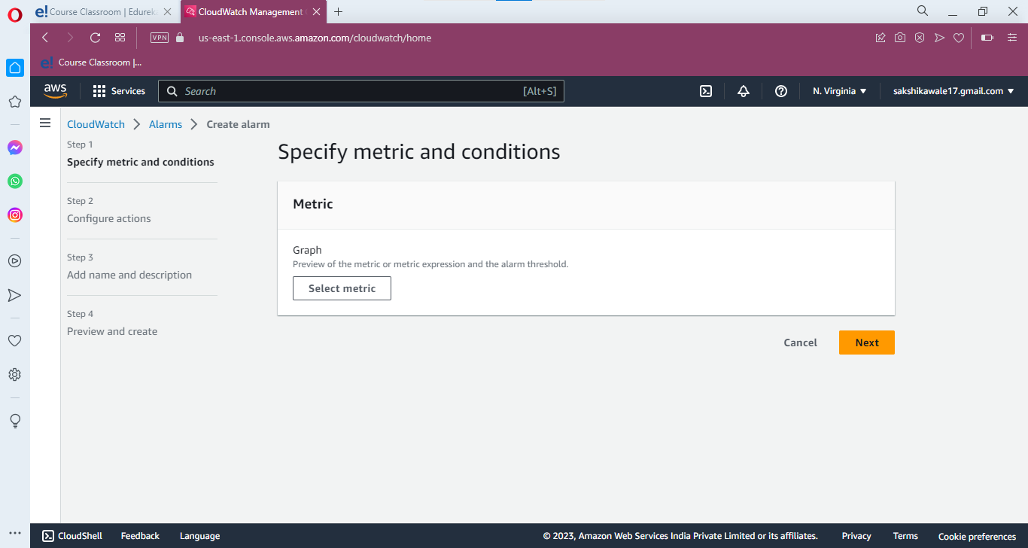

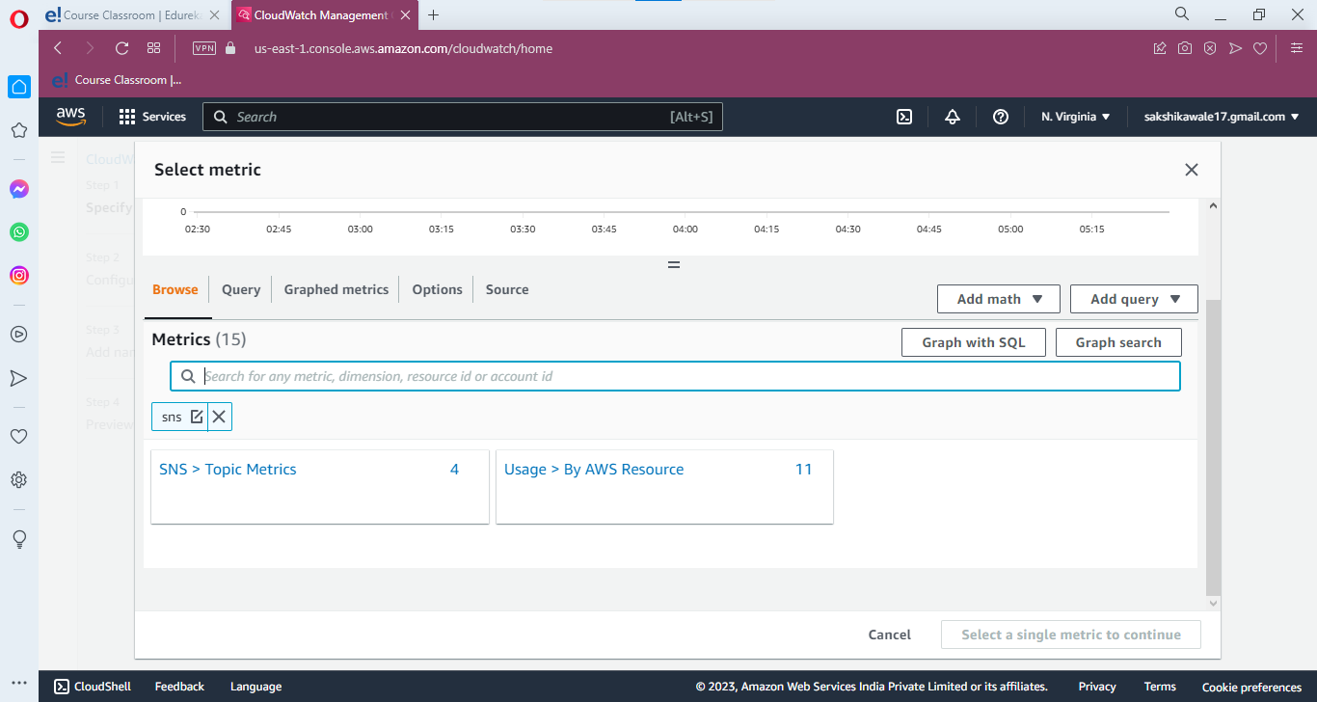

Click on SNS topic metrics

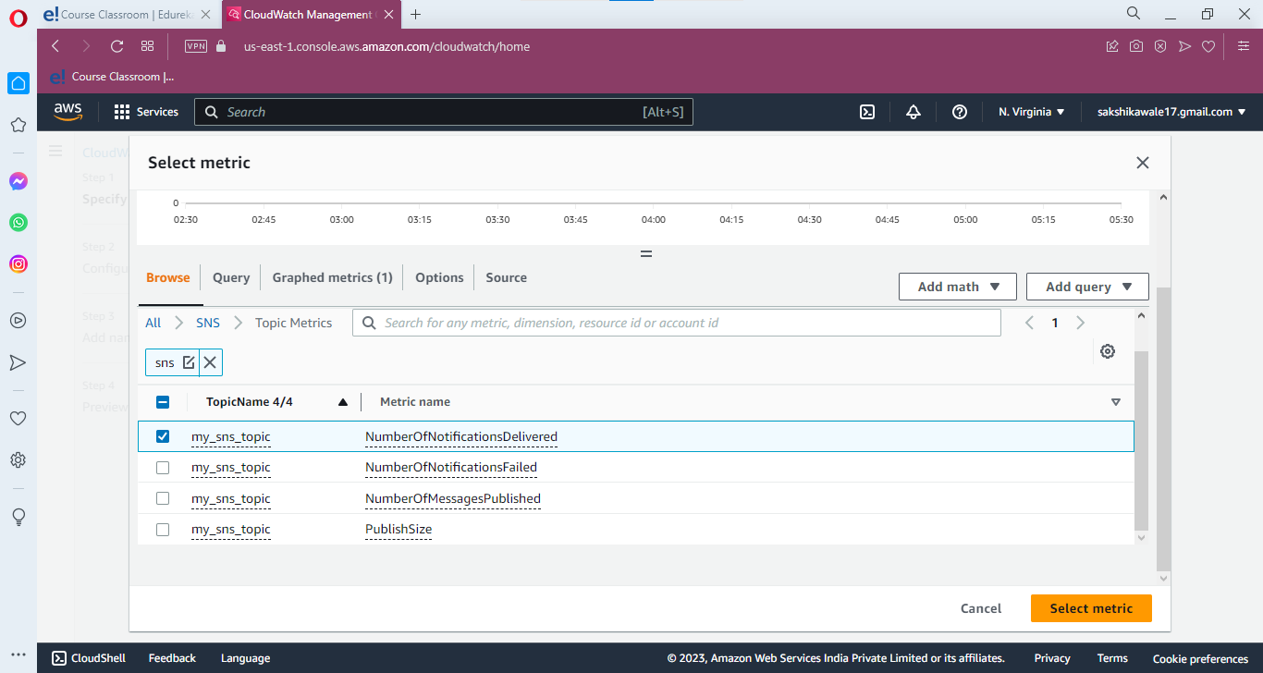

Then click on select metric

